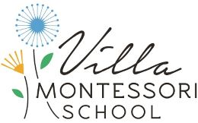
2023-2024
2:30 – 6:00
Gloria Favela

Welcome to the Primary Circle Program! My name is Gloria Favela, and I am the Primary Circle Coordinator. We are excited that your child is participating in our after-school activities, please read our program information below.

To Contact Me
To contact me with any questions or concerns at any time, about the Circle Program, the best way to reach me is via email at gfavela@villamontessori.com. Circle staff does communicate on a regular basis with the lead teachers. Please direct your questions concerning the academic portion of the day to your child’s lead teacher. Thank you.

Daily Schedule:
2:30 - Playground
3:00 – Snack
3:30 – Inside Activity/Working from Circle Shelves
5:00 – Playground
5:30 – Inside Activity/Working from Circle Shelves

Snack
Please provide an adequate healthy snack for your child daily. Circle snacks are to be packed in a reusable container labeled “Circle Snack,” inside your child’s lunchbox. Please refer to your child’s Welcome Letter regarding elegance and other items your child may need for snack, such as a placement.

Pick - Up
When picking your child up, please pull into a parking spot and ring the doorbell at the gate. A staff member will meet you at the gate with your child and his or her belongings.

We are looking forward to a great year!
Gloria Favela

