**Two-Dimensional Shapes**

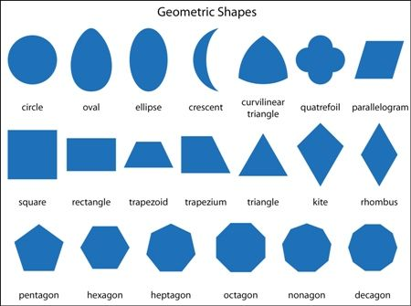

**Three-Dimensional Shapes**

